Analysing reports using Test Result Analyzer plugins

1. Start Jenkins Dashboard.

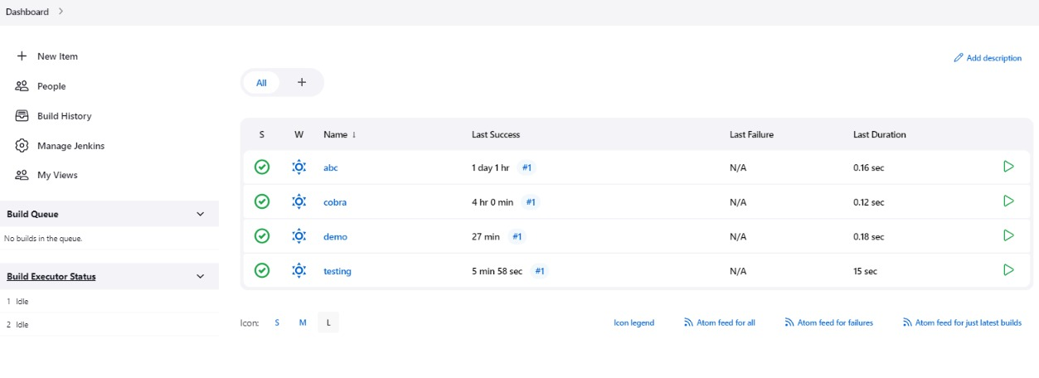

1. Go to Manage Jenkins

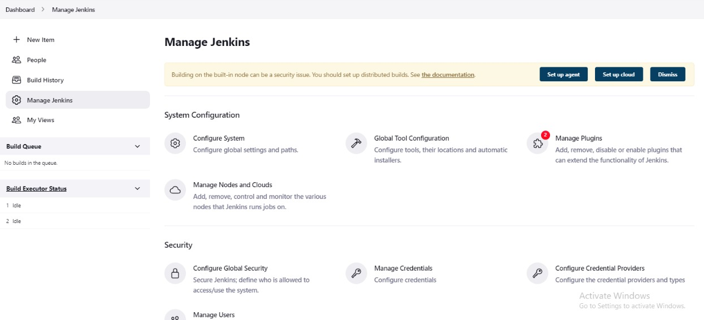

1. Go to plugin manager and download plugin Test Results Analyzer

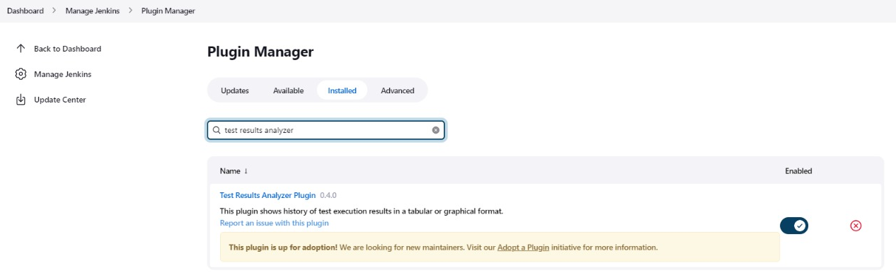

1. Create a Freestyle job with the name Testing



1. Add a repository with test cases <https://github.com/Sonal0409/simple-java-maven-app.git>

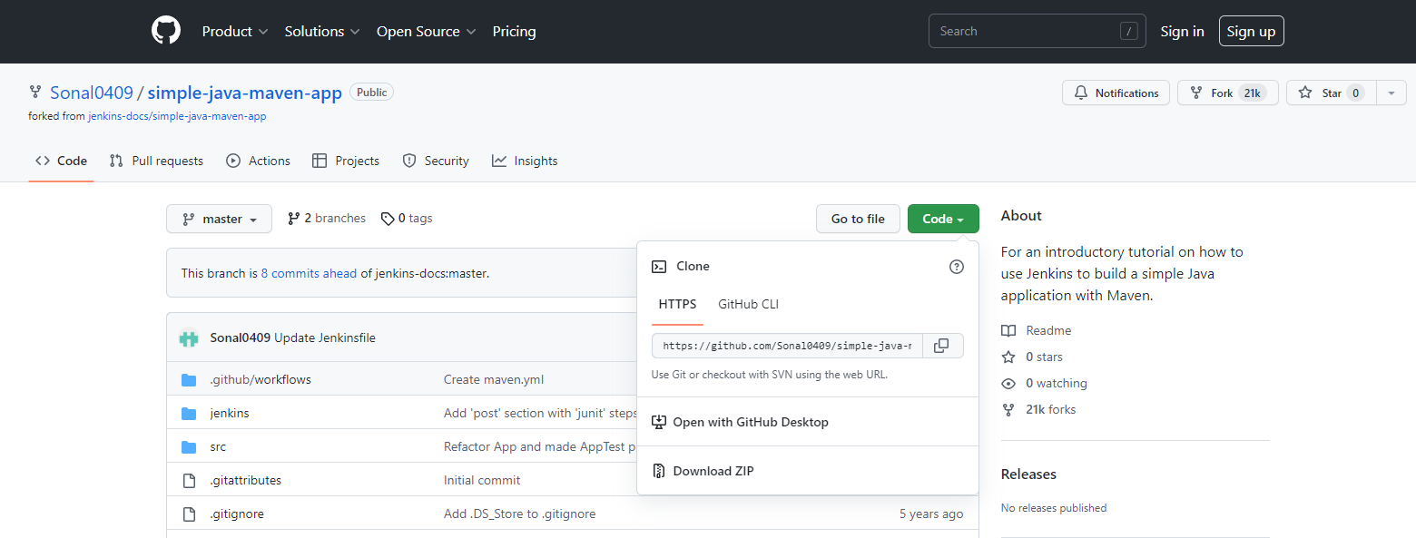

6. Write the build steps to execute the maven command for testing

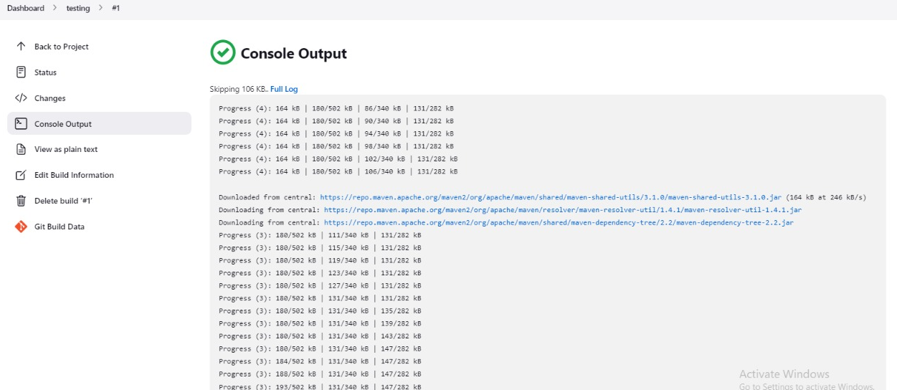

7. Build the job multiple times

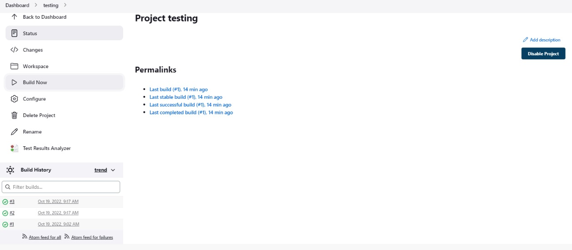

8. Observe the test Analyzer report and compare the test builds

